68

Recipe for Success
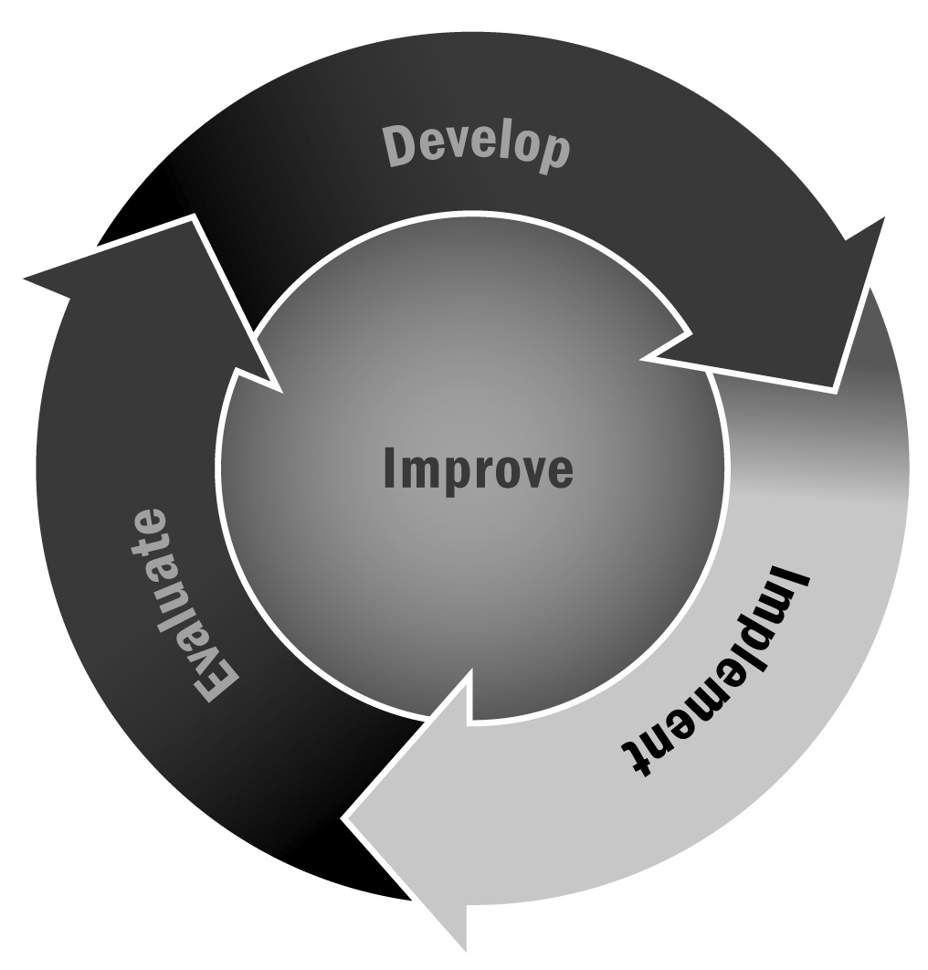
In Chapter 4, you learned about supporting positive behavior in programs. Creating a recipe for success with young people involves them in the process of setting behavior expectations and helps gain their buy-in.
Directions: Creating a recipe for success can be as simple or as elaborate as you make it. Below are a few ideas to get you started, but feel free to exercise your creativity. This activity works well at the beginning of a new school year or program cycle to develop expectations that will last throughout the year, or at the beginning of a session or specific activity to last the duration of the session or activity.

Basic Recipe for Success
- Gather together the group of youth you are working with and ask them to think about what they might need from each other to have a successful year, session, or activity.
- Depending on the age group you are working with, you can have them take turns writing down what they think of on a large piece of flip-chart paper, or you can have them take turns calling out what they think of and you can record their answers. Be sure to make yourself part of the group so that you can include things you think are important.
- If the group has a hard time getting started, you might want to prompt them with things like listening to each other, waiting your turn to talk, keeping a positive attitude.
- Once the group has exhausted their ideas, review everything that was said. Provide time for any last-minute additions.
- Have everyone in the group, including you, agree to the things written on the flip-chart paper by signing their names. You can then hang the paper up in a prominent location as a reminder of the agreed-on expectations for the group.
- Refer back to the recipe for success throughout the year, session, or activity. Check in with young people about certain concepts that might be more abstract, such as keeping a positive attitude, and discuss what this looks like during the activity.
Variations for Creating a Recipe for Success
- Pirate Map: Create a pirate map before you meet with the young people in your program. The starting point should be the beginning of the year, session, or activity, and the treasure should signify the successful end of the year, session, or activity. The map can wind and twist and turn along the way. As with the basic directions above, have young people write on the map what they will need from the group to successfully reach the treasure.

- Baking Cookies: In this variation, you are creating an actual “recipe” for success. This works particularly well for elementary-age youth. As young people are calling out what they might need from the group to be successful, you can make a list with measurements (e.g., one cup of listening, two tablespoons of cooperation). When you have listed all of the ingredients, remind youth that when everything is mixed together they make delicious cookies.
- Leaves on a Tree: Use construction paper to cut out enough leaves for each of the young people to have at least one. Draw a large tree trunk on a piece of flip-chart paper. When you introduce the activity, have young people write down and/or draw what they will need from the group on their leaf. Once everyone is finished, have them present their leaf to the group and tape the leaf to the tree.
- Puzzle Pieces: Create a large puzzle ahead of time using cardboard. As with the leaves example above, each young person gets one piece of the puzzle on which to write down and/or draw what they will need from the group. Have everyone present what they wrote or drew and then have the group put the puzzle together. You can then stress the importance of each of their pieces in making the group successful.

